1. At what point during mitosis does proteolytic cleavage of cohesin proteins occur?
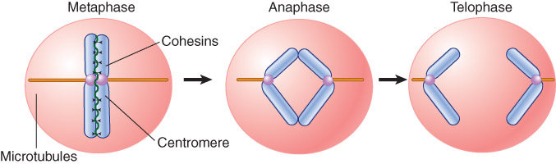
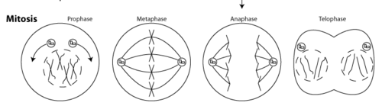
- anaphase
- prophase
- metaphase
- telophase

2. The “intergenic” parts of the human genome (i.e., the portion of the genome that does not encode proteins or structural RNAs) consist of which types of DNA sequences?
- genome-wide repeats, microsatellite DNA, and regulatory sequences
- introns, gene fragments, and pseudogenes
- genome-wide repeats, pseudogenes, and microsatellite DNA
- introns, regulatory sequences, and microsatellite DNA

3. A nucleosome forms hydrogen bonds with what part of the DNA?
- with the phosphodiester backbone and with bases via the minor groove
- only with bases via the major groove
- only with bases via the minor groove
- with the phosphodiester backbone and with bases via the major groove

4. Which of the following enzymes is directly responsible for sliding DNA along the surface of an assembled nucleosome, or transferring a nucleosome from one DNA helix to another?
- nucleosome-remodeling complexes
- histone chaperones
- histone acetyltransferases
- Topoisomerase II

5. Which of the following is not a telomeric function?
A. allowing extension of the telomere
B. protection of the chromosome end
C. providing a site of origin for DNA replication
D. All of these are telomeric functions.

6. Why would the absence of DNA primers in PCR cause the reaction to fail?
- The reaction lacks template DNA when primers are absent.
- The reaction lacks a primer:template junction, and thus a free 3′-hydroxyl group, when primers are absent.
- The reaction lacks a free 2′-hydroxyl when primers are absent.
- The reaction lacks single-stranded DNA when primers are absent.

7. DNA polymerase ensures that the correct nucleotide is incorporated into the growing strand of DNA by __________.
- detecting the identity of the incoming nucleotide
- specifically binding only the correct nucleotide in
the active site
- selecting the correct nucleotide in a exonuclease active site in the DNA polymerase
- monitoring the ability of the incoming nucleotide to form either an A:T or G:C base pair

8. Which of the following is true regarding the direction of new DNA synthesis during replication?
- The lagging strand DNA polymerase synthesizes DNA in the same direction that the replication fork is moving.
- The leading strand DNA polymerase synthesizes DNA in the same direction that the replication fork is moving.
- The leading and lagging strand DNA polymerases synthesize DNA in the 5′ to 3′ direction, which is in the same direction that the replication fork is moving for either strand.
- The leading strand DNA polymerase synthesizes DNA in the 5′ to 3′ direction, while the lagging strand DNA polymerase synthesizes DNA in the 3′ to 5′ direction.

9. Which one of the following factors significantly contributes to the ability of eukaryotic cells to complete DNA replication during the short window of time offered by S phase?
- The next round of replication begins before the cell exits S phase.
- Eukaryotic DNA polymerases have dramatically increased processivity compared to DNA
polymerases in organisms with smaller genomes.
- Multiple origins of replication are activated per chromosome.
- Origins of replication can initiate again after they have been replicated and before mitosis.

10. Which of the following statements correctly describes the role of telomerase in eukaryotic cells?
- It synthesizes the Okazaki fragment needed to prevent loss of genetic information at the 5′ end of the chromosome.
- It synthesizes new DNA (using a RNA template) at the 3′ end of the chromosome.
- It synthesizes new DNA (using a DNA template) at the 3′ end of the chromosome.
- It synthesizes DNA on both the 5′ and 3′ ends of the chromosome.

